Part I Research Question

Research Question
How accurately can we predict Bandwidth usage?

Goals of Analysis
Predicting Bandwidth usage for projection purposes, if the company is forecasting a surge in customers in some areas it may be useful to predict the increase in bandwidth that must be added to ensure the internet speed and quality will remain the same after the growth in customers. Our goal is to build a model that is highly accurate as an aid in forecasting bandwidth usage.

Part II Method Justification

Explanation of Ridge Regression
Ridge Regression operates very similar to a normal Linear regression model, except Ridge performs regularization to prevent overfitting and bias from creeping into the model using a constant alpha coefficient. When we perform hyperparameter tuning we will be tweaking the alpha coefficient slightly to find the most accurate model. An alpha of 0 returns the Ridge model back into an Ordinary Least Squares regression model.

Assumptions of Ridge Regression
Response and Explanatory variables are linearly related, if this is true, we should be able to get a relatively powerful regression model.

List of Libraries and Packages Used
Library | Package | Description
pandas |  | Used for data wrangling and storing data in a dataframe
Seaborn & matplotlib.pyplot |  | Used for data visualization
scipy | stats | Calculating z-scores to find outliers
numpy |  | Used to quickly manipulate arrays
statsmodels | Variance_inflation_factor | Used to assess multicollinearity
sklearn | Model_selection | Train_test_split, GridSearchCV, cross_val_score, to ensure the model had training and test datasets, the model’s hyperparameters were optimal and to cross validate the test performance.
 | metrics | Metrics to calculate the model performance, r2_score, mean_absolute_error, and mean_squared_error
 | Linear_model | Usage of Ridge regression model from sklearn

Part III Data Preparation
Preprocessing Goal

The main goal of preprocessing will be recoding the categorical variables into numeric values via ordinal encoding or dummy variables. This will allow us to include the categorical variables in the regression model and enable us to do multicollinearity assessment of the explanatory variables with Variance Inflation Factor from statsmodels.

Initial Dataset Variable Description

Children Numeric, Multiple Categorical, Tenure Numeric,
Streaming TV Categorical, Streaming Movies Categorical, Churn Categorical,
Internet Service Categorical, Bandwidth_GB_Year Numeric.

Preparing the Data

Identifying Outliers

cols_numeric = [x for x in data.columns if (data[x].dtype != 'object') & (x != 'Churn')]
dodge = ['Bandwidth_GB_Year','Tenure']
# Iterates through numeric columns calculating z scores
# Tracking outlier indexes in ind
outliers = []
for i in cols_numeric:
count = 0
if i not in dodge:
# list of z scores for column
z = list(stats.zscore(data.loc[:,i]))
# Stores index of outlier values in column
ind = []
val = []
# Finding outliers
for zscore in z:
if (zscore >= 3) | (zscore <= -3) & (z.index(zscore) not in ind):
ind.append(count)
val.append(data.loc[count,i])
count+=1
# Dropping outliers in unimodal distributions
if len(ind) > 0:
print(i,len(ind))
outliers.append([val,i])

Removing Outliers

min_val_children = np.min(outliers[0][0])
data = data[(data['Children'] < min_val_children)]

Categorical Variable Transformation

#Ordinal Encoding
for i in cat_cols:
if i not in ['InternetService','Children']:
data[i] = data[i].map({"Yes":1,"No":0})
#Dummy Variables
data = pd.get_dummies(data)
data = data.drop(columns = ['InternetService_None'])

Assessing Multicollinearity

from statsmodels.stats.outliers_influence import variance_inflation_factor
X_cols = [x for x in data.columns if x not in ['Bandwidth_GB_Year']]
y = data['Bandwidth_GB_Year']
X = data[X_cols].copy(deep = True)
print([(X.columns[i],variance_inflation_factor(X.values,i)) for i in range(len(X.columns))])

Clean File
task_1_clean.csv

Part IV Analysis
Split Data

Testing Data
task_1_test.csv

Training Data
task_1_training.csv

Analysis Techniques

Comparison of Model Performance

By comparing the r-squared, mean absolute error, and mean squared error between the training, test and using cross_val_score we can determine how well the model fits to the training data, and gain a glimpse into how well the model will perform in production with cross validation.

The model performs similarly well across all three performance evaluations with a very high fit and low error.

Visualizing Residual Distributions

Residuals should be evenly distributed across the mean so viewing the residual distributions across all explanatory variables can help us see which variables break the assumption of a present linear relationship.

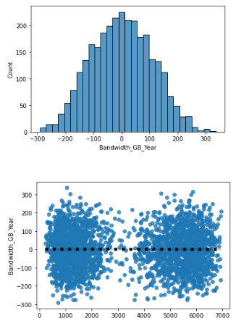

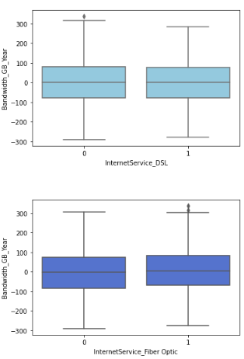
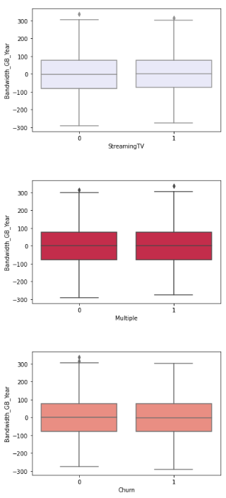
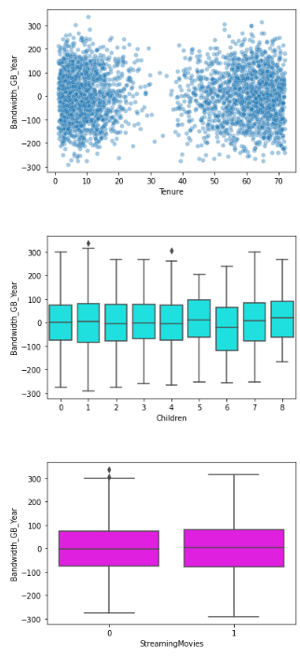
I used boxplots when looking at how residuals were distributed among our variables, nothing out of the ordinary except the linear relationship between the number of children and bandwidth doesn’t appear to be as strong when the number of children surpasses 6.

Code for Analysis

Comparing Model Performances

print('Test Performance')
print("R-Squared",r2_score(y_test,y_pred))
print('Mean Absolute Error',mean_absolute_error(y_test,y_pred))
print("Mean Squared Error",mean_squared_error(y_test,y_pred))
print("\nTest Performance Cross Validation")
r2_test = cross_val_score(estimator, X_test,y_test,scoring = 'r2').mean()
mae_test = cross_val_score(estimator, X_test,y_test,scoring = 'neg_mean_absolute_error').mean()
mse_test = cross_val_score(estimator, X_test,y_test,scoring = 'neg_mean_squared_error').mean()
print("R-Squared",r2_test)
print('Mean Absolute Error',-mae_test)
print("Mean Squared Error",-mse_test,'\n')

Viewing Residual Distributions

Base Residual Distribution
residuals = (y_test-y_pred)
sns.histplot(x = residuals)
plt.show()
sns.regplot(x = y_pred, y = residuals,
line_kws = {'color':'black','linestyle':'dotted','linewidth':5})
plt.show()

Explanatory Variable Residual Distributions

sns.scatterplot(x = X_test['Tenure'],y = residuals,alpha = .4)
plt.show()
sns.boxplot(x = X_test['Children'],y = residuals, color = 'aqua')
plt.show()
sns.boxplot(x = X_test['StreamingMovies'],y = residuals, color = 'magenta')
plt.show()
sns.boxplot(x = X_test['StreamingTV'],y = residuals, color = 'lavender')
plt.show()
sns.boxplot(x = X_test['Multiple'],y = residuals, color = 'crimson')
plt.show()
sns.boxplot(x = X_test['Churn'],y = residuals, color = 'salmon')
plt.show()
sns.boxplot(x = X_test['InternetService_DSL'],y = residuals, color = 'skyblue')
plt.show()
sns.boxplot(x = X_test['InternetService_Fiber Optic'],y = residuals, color = 'royalblue')
plt.show()

discrete = ['Children','Multiple','StreamingMovies',
'StreamingTV','Churn','InternetService_DSL','InternetService_Fiber Optic']
X_test['Residuals'] = residuals
for i in discrete:
print(X_test.groupby(i)['Residuals'].describe())

Part V Data Summary and Implications

Model Performance

The model performs well in training, test, and production environments. Mean absolute error of 88 between the 3 models and an r-squared of .99 shows the model performs very well, but certainly suffers from overfitting as our mean squared error is very high at a 11770 average between the test and cross validation unseen models. It appears the outlier effects are slightly higher in cross validation testing. Looking at our residuals we can see the distribution has a range of 600 from -300 to 300, normally distributed across the mean of 0, which explains the outlier effect being so high.

Results of Prediction Analysis

The model performs with high accuracy, but most likely suffers from overfitting. The residuals are evenly distributed across all variables. Judging from our coefficients we can say tenure has the highest predictive power and DSL internet service’s relationship with bandwidth is much different than customers with fiber optic or none internet service.

Limitation of Analysis

The limitation of analysis is the assumption of the explanatory variables being linearly related to the response variable because as time goes on the linear relationship between the variables may decay and the model will become increasingly inaccurate.

Course of Action

This model performs well, however there is a huge issue of overfitting. Overfitting generally indicates the model will be weak in production and will become outdated from industry trends much quicker than a typical model. I personally wouldn’t use this model for the general problem. I would retrain a similar model on clusters of customers to bring more accuracy and reduce the significance of the overfitting as clustered customers will have more similarities than this general dataset. A con of this method is that it increases the computational cost of prediction, but it may be more accurate and a more feasible long-term solution for this problem. Outlier effects may also be reduced by transforming the bandwidth column into weekly bandwidth, or removing the Children variable possibly, but there needs to be additional testing to be sure.

